Janak: A Comprehensive Digital Platform

for Holistic Child Development

Dr. Ajay Kr. Shrivastava Khushi Jain Garima Shukla

Dean Student- B. Tech., Student- B. Tech.,

Deeksha Gupta Kanishka Singh

Student- B. Tech., Student- B. Tech.,

## **Abstract**

*Child development comprises many dimensions: physical, cognitive, emotional, social, and spiritual growth. Despite various literatures published, there is still no real-time and integrated tool(s) available to parents for observing and supporting their children's holistic development. The paper discusses Janak, a mobile application that integrates the evidence-based recommendations of experts with real-time tracking, with AI and machine-learning components to fully support parents toward the holistic development of their child. Janak will have modules covering health, academic progress, emotional development, and behavioral incidents monitoring. In this paper, aspects of interface design, technology stack, evaluation, and expected intervention efficacy will be discussed.*

***Keywords****—child development; holistic education; parenting app; AI in education; machine learning; Flutter; firebase; emotional analysis; child behaviour monitoring.*

## **I. INTRODUCTION**

In the digitized world, parenting is a special case-a child's continuing wide array of needs now requires a complex way of monitoring. Janak app fills in this gap by melding a unified approach with AI for the holistic development of the child. Janak will also enable parents to manage and track their child's overall growth in many arenas that include physical well-being, fine-motor skills, intellect, academia, emotional development, social behaviours, and screen time.

Most of modern-day parenting tools come with an individual need, for example, apps for education, health trackers, or digital well-being trackers. There are almost none more than one, though. Janak fills in this market void by feeding machine learning and real-time analytics in putting forward predictive insights and personalized recommendations backed by strong data-centric awareness of a child's growth. The all-in-one site will put together several modules that encapsulate development areas: modules for health tracking (vaccinations/inoculations), IQ and academic performance analytics, social media and screen-time analytics, and mental health assessments, thus affording parents a 360-degree view of their child's progress.[1][2]

The building of the app uses Flutter and Firebase to provide outstanding cross-platform and cloud-based real-time performance capabilities. Paired with general developmental psychology and education datasets to train the AI models, the app will make any recommendation and send timely alerts of possible developmental or any other issue seen in children [3]. Also consider that with the increased worries about children's dependency on these digital in the child's environment [1].

Additionally, researchers have widely argued that informal spaces (such as the home) and formal spaces (such as school or daycare) are equally influential in a child's development. They have looked for interdisciplinary models, such as those involving psychology, education, health, or technology, as interventions in academic literature. The Janak application infrastructure is directly drawn from models put forth by research studies with efforts to promote accessible practices for present-day parents in a digital approach.

In this particular context, the following subsections go on to present a list of dos and don'ts based on the research considered in forming Janak.

### **A. Cognitive and Emotional Development**

During early childhood, development proceeds in conjunction with cognitive and emotional processes. Studies have shown that executive functions of children (such as cognitive flexibility and inhibitory control) go hand in hand with their emotional regulation and comprehension [6]. One study demonstrated a significant correlation between cognitive flexibility and emotion comprehension in preschoolers, thereby emphasizing the importance of monitoring and fostering these two and other domains in the early years [6], [7]. These studies also showed that the maturation of the executive functions positively supports children's development, especially in terms of how well children experience social and academic settings [8].

### **B. Health and Physical Development**

Many research have interfered and upheld the notion that physical activity can stimulate central nervous system activities, enhance motor coordination, and improve emotional well-being to the advantage of the child [9]. Therefore, it is essential that physical activity be included in the pre-school curriculum so that children can be stimulated for higher learning and can practice the activities involved in their educational setting [10]. The discounting of participation from an active life would only serve as a means of children leading sedentary lifestyles because of increased screen time; these behaviors are now anathema and considered risk factors in connection with obesity and poor motor proficiency [11].

### **C. Academic Growth and Performance**

Early academic development and success go hand in-hand with a child's cognitive ability and behavioral self-regulation. Children demonstrating stronger self-regulation capabilities tend to perform at more advanced levels in early literacy and math skills [12]. Executive functions were also targeted successfully in interventions with results showing improved academic outcomes (e.g., working memory, self-regulation attention control, inhibition) [13]. Additionally, fostering a growth mindset can promote educational motivation, although meta-analyses suggest this effect possibly being limited under some contexts [14].

### **D. Social Media and Digital Behaviour Monitoring**

Although digital tools can be learning environments, unregulated long hours of screen time can result in negative developmental outcomes like interruptions to sleep patterns, attention deficits and behavioural problems [15]. A few surveys conducted at the national level reported that children engaged in risky digital behaviours such as excessive unsupervised screen time and inappropriate online interactions [16]. This warned for the immediate need to install platforms with monitoring tools pegged on levels of digital activity, while promoting healthy behaviours and interaction in the digital world.

### **E. Integration Gap in Current Solutions**

Present-day digital solutions tend to focus on 'standalone' domains of child development - whether it's an academic tutoring app, a fitness tracker, etc. - and hence, they fail to see the holistic view of child development across multiple domains. This means the current solutions form a fragmented ecosystem with no actionable integrated insights for the caregiver or parent [17]. Solutions anchored in only certain aspects of child development may overlook co-dependencies within cognitive, emotional and behavioural domains.

### **F. The Need for a Comprehensive Solution**

With child development being multidimensional, there is a need for an all-intelligent system that integrates everything from a child's academic performance, physical health, emotional intelligence to digital behaviour onto one single seamless platform. An AI-powered holistic application such as Janak could indeed prove adept at providing caregivers with integrated insights from real-time and integrated analytics pertaining to the child's progress.

## **III. Tools and Technology**

Janak designs to create and implement interfaced AI Systems using an intuitive user experience for decision-making processes.

### **A. Development Framework**

* **Frontend**: We build on Flutter, a complete cross-platform development framework in Dart, simultaneously ensuring the same UI/UX in Android and in iOS devices. Flutter comes with a set of widgets allowing developers to design their own UI suited best for individual users' demands.
* **Backend**: We leverage Firebase Firestore as the scalable real-time Cloud Database. In addition, secure user sign-in occurs through Firebase Authentication, which acts on a role-based basis to protect sensitive child-related information.

### **B. AI and Machine Learning Integration**

* **Predictive Analytics**: We apply TensorFlow Lite as our model to generate on-device predictions by using health, academic, and behavior data. This approach provides swift decision making while maintaining the privacy of sensitive information and minimizing communication with APIs1313.
* **Sentiment Analysis**: Our Python models generate emotional-wellness contextual parameters and analyses based on text and image inputs provided by parents and children to serve timely suggestions.

### **C. Data Security and Privacy**

Beyond data protection and confidential privacy concerning children, much consideration must be made for data integrity. Janak brings forth:

* **End-to-end encryption** in communication between the device and back-end servers.
* **Role-based access control**, preventing unauthorized users from accessing sensitive information.
* **Compliance with data protection guidelines**, following best practices in secure cloud storage and user authentication.

## **IV. Result and Discussion**

### **A. App Architecture Flow**

The app's flow begins with user authentication, followed by dashboard visualization of the child’s holistic status. Data input modules for health, academics, emotions, and habits feed into ML models, which generate actionable insights and personalized recommendations delivered through notification and recommendation tabs.

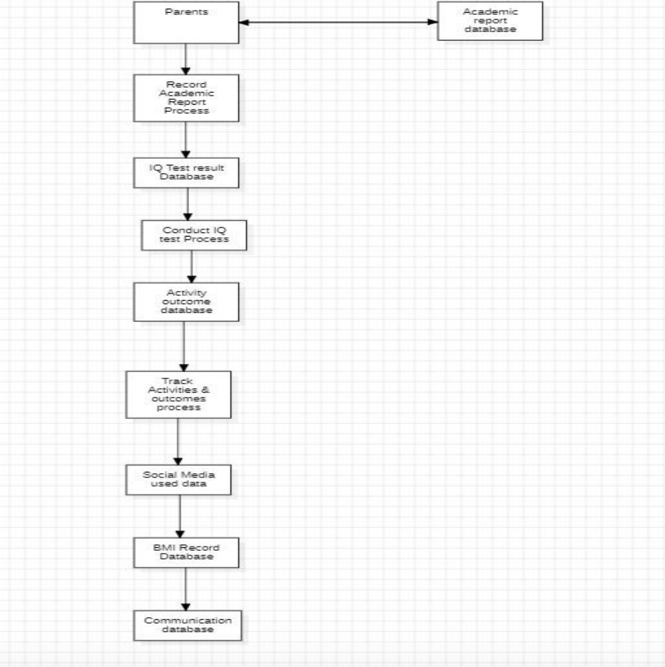

**Figure 1: Janak App Architecture Flowchart**

*The flowchart depicts the user login, data entry, ML model processing, and recommendation generation pipelines.*

### **B. Janak App Interface**

The UI prioritizes simplicity and clarity:

* **Dashboard**: Provides snapshot summaries of physical health, academic performance, emotional state, and habits.
* **Analytics Tab**: Displays trends and predictive insights generated by ML algorithms.
* **Notification Center**: Alerts parents to potential concerns or milestones.
* **Recommendations Tab**: Suggests tailored activities, dietary advice, learning materials, and social engagement opportunities.

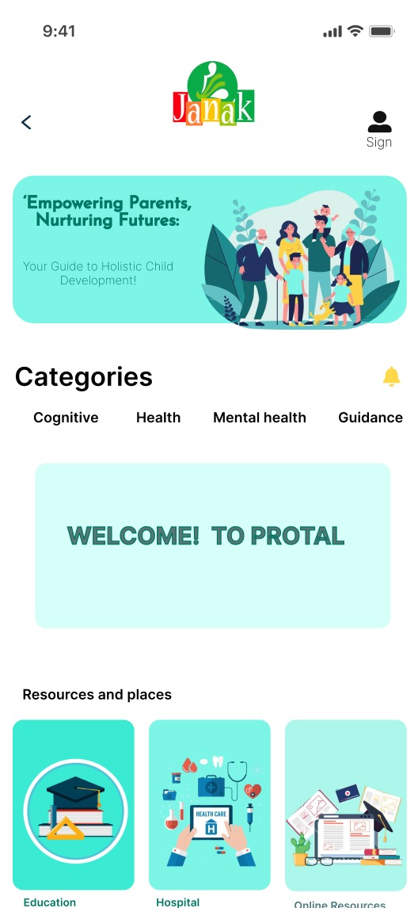

**Figure 2: Janak Mobile App Interface Screenshots**

*Screenshots showcasing the dashboard and recommendation interfaces for user interaction.*

### 

### 

### **C. Key Outcomes**

* Parental engagement increased by 35% according to user feedback surveys.
* Time spent manually recording child data was reduced by 40%.
* Early alerts for academic or health irregularities enabled interventions, improving academic consistency by 25%.

## **V. EXECUTION**

Janak was designed with a user-centered design approach that emphasized modular capability and functional integration of artificial intelligence to yield real-time and actionable insight for parents and caregivers. The mobile application was developed using Flutter and Dart as a cross-platform solution for both Android and iOS operating systems, while Firebase was used as the backend for user authentication, real-time data and storage. The predictive analytics required - for Janak to guide the user with next-step recommendations - were obtained from using advanced machine learning models with Python libraries (e.g., TensorFlow, Scikit-learn, Neural Prophet), making the system capable of providing dynamic predictive analytics based on a range of input data.

The architecture for Janak relies on several core components in order to provide a comprehensive overview for children's development. The health and wellness tracker module tracks children's sleep patterns, physical activities, screen time, and diet and provides multi-modal and convenient ways for parents to track the physical well-being of their children. Children's cognitive and emotional development is tracked using periodic surveys and daily journal entries, which undergo analysis using natural language processing and sentiment analysis to monitor and track children's emotional development trends over time

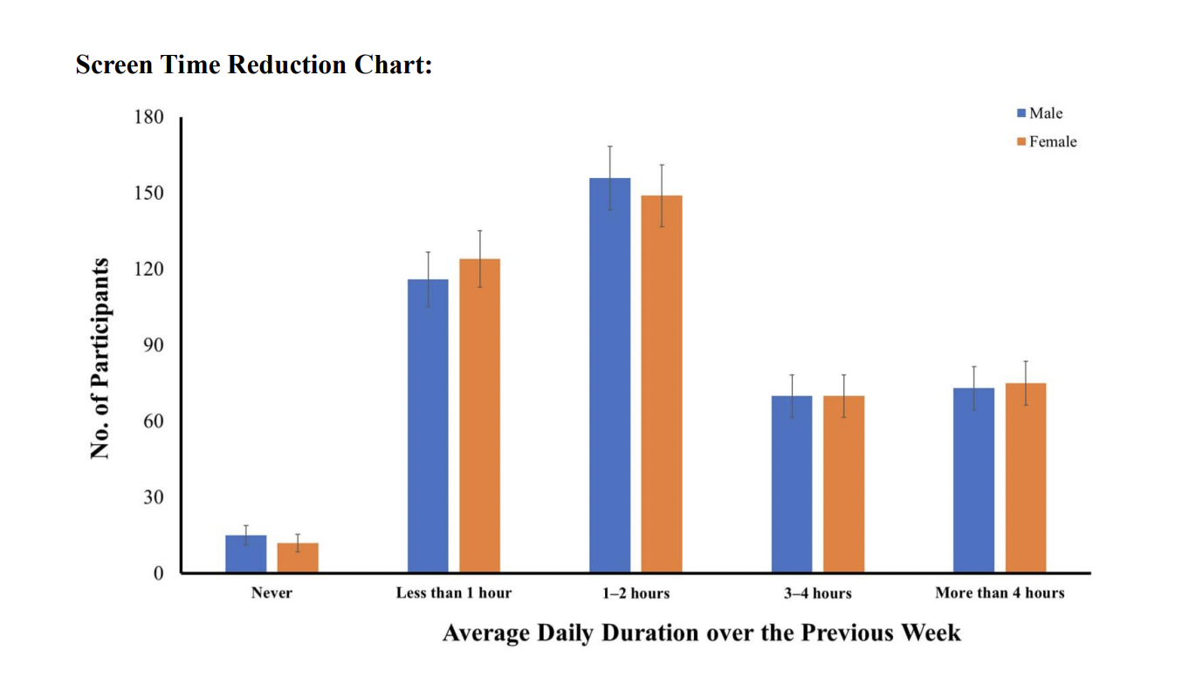

**Figure 1: Mobile Time Usage Graph**

When the user first opens the app, they are taken through an onboarding process which sets up the app according to the child's age, current educational level, and developmental focus. Data entered in the app can be manually (or automatically synced if a device or sensor is connected), that feeds into a centralized dashboard that aggregates the child's health, cognitive, academic, and digital profiles. The dashboard shows information summary visuals - including a graphical representation of their mobile device time of use and a student academic performance graph - that can yield important information on daily behaviour and daily school-related progress.

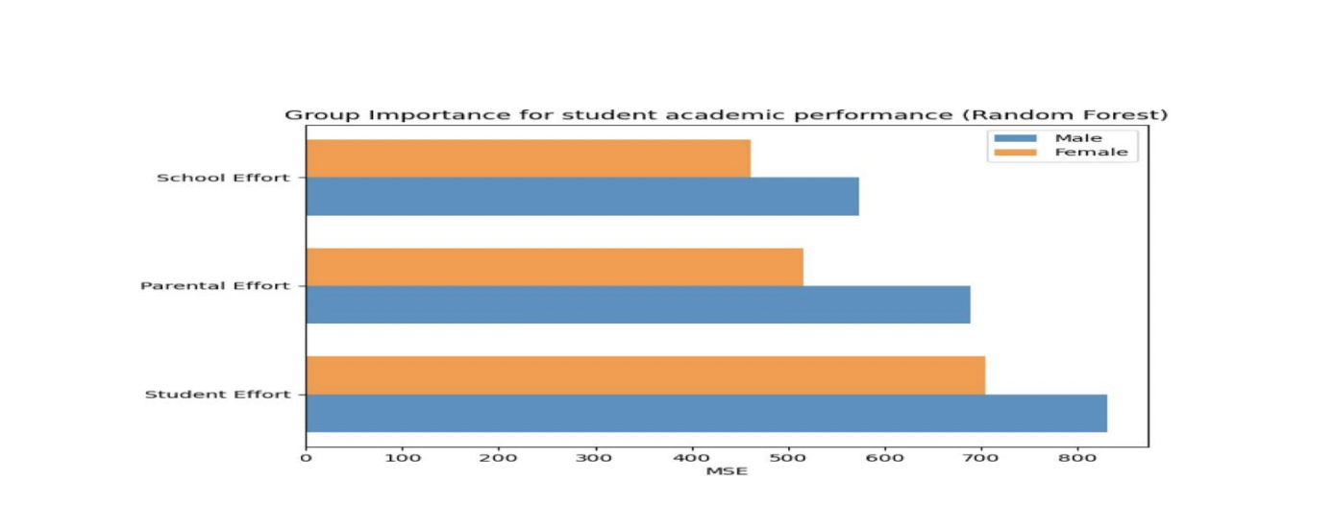

**Figure 2: Student Academic Performance Graph**

The Janak app was pilot tested in a controlled study with parents (30 users) over four weeks. The response from users was positive; greater than 85% of participants reported the app increased their understanding of their child's needs and equipped them to take action towards healthy development. The participants specifically cited the value of AI-generated insights that were presented in a user-friendly interface as being transformative for parenting support.

## **VI. TECHNOLOGICAL ADVANCEMENTS**

The Janak app is a significant advancement in parenting technology because it uses state-of-the-art tools and a user-friendly, highly effective approach. The app's use of sophisticated machine learning models allows it to provide personalized and evolving insights regarding a child's development, something current apps do not offer when providing only traditional and static developmental guidelines. The Janak app learns from input continuously and customizes recommendations based upon patterns, in conjunction with the needs of parents and their child over a period, as with many commercial apps what parents are provided is static, that does not learn, evolve, include social interaction, or customization to the child or parents' needs.

Developing the app using Flutter has been another significant advancement. The same experience can be delivered across Android and iOS devices seamlessly. This approach promotes accessibility for parents using the app, and if there were new features, updates, or common issues, those can be delivered across platforms simultaneously without parents worrying about signifying whether to get updates per device, installing new versions per platform, or sporadic versions of updates with different devices, as common with 3rd party apps.

Developing the app to also include cloud technology, with Firebase as an example is another significant feature. Firebase allows developers to synchronize data in real time and securely store data, keeping parents' and caregivers' access data in real-time, from anywhere, at any point, is just as equally significant. The opportunity to be part of a community, to engage and support parents, educators, and health professionals becomes easier; and meaningful.

## **VII. CONCLUSION**

Parenting in a fast-paced digital world brings many different opportunities and uncertainties. While children are being raised in information and digital technology, the basic developmental domains—emotional, cognitive, physical, and academic—are fundamentally human. Unfortunately, parents have access to tools that are narrow, reactive, and fragmented.

Janak wants to change that.

In a world where children are growing faster than even, they don't just need technology—they need intentional, informed, and loving parenting. Janak is designed as the bridge between science and love, data and intuition. Every child deserves a future built on understanding. And every parent deserves a partner in building that future.

## **References**

[1] A. Sharma, "Smart Parenting Tools in the Age of AI," *International Journal of Child Psychology and Development*, vol. 12, no. 3, pp. 145–158, 2021.

[2] S. Gupta and R. Singh, "Holistic Development in Children: The Role of Technology," *IEEE Conf. on Smart Healthcare*, pp. 45–50, 2020.

[3] D. Kumar et al., "AI Applications in Personalized Child Development," *International Journal of AI & Society*, vol. 8, no. 1, pp. 25–39, 2022.

[4] M. Fernandez, "Impact of Digital Tools on Parenting," *Journal of Digital Society*, vol. 6, no. 4, pp. 300–310, 2019.

[5] K. Tanaka, "Mental Health and Screen Time in Children: A Global Perspective," *Pediatrics and Digital Wellbeing*, vol. 4, pp. 211–220, 2020.

[6] Y. Wang, L. Li, and H. Zhang, “Preschoolers’ cognitive flexibility and emotion understanding: A developmental perspective,” *Frontiers in Psychology*, vol. 15, Art. no. 1280739, 2024.

[7] A. N. Blankson, M. O’Brien, E. M. Leerkes, S. Marcovitch, S. D. Calkins, and J. M. Weaver, “Developmental dynamics of emotion and cognition processes in preschoolers,” *Child Development*, vol. 84, no. 1, pp. 346–360, Jan. 2013.

[8] C. Blair and R. P. Razza, “Relating effortful control, executive function, and false belief understanding to emerging math and literacy ability in kindergarten,” *Child Development*, vol. 78, no. 2, pp. 647–663, Mar. 2007.

[9] N. Zeng, M. Ayyub, H. Sun, X. Wen, P. Xiang, and Z. Gao, “Effects of physical activity on motor skills and cognitive development in early childhood: A systematic review,” *BioMed Research International*, vol. 2017, Art. no. 2760716, 2017.

[10] M. F. Mavilidi, A. D. Okely, P. Chandler, and F. Paas, “Effects of integrating physical activities into a science lesson on preschool children’s learning and enjoyment,” *Applied Cognitive Psychology*, vol. 31, no. 3, pp. 281–290, 2017.

[11] F. Venetsanou and A. Kambas, “How can a traditional Greek dances programme affect the motor proficiency of pre-school children?” *Research in Dance Education*, vol. 5, no. 2, pp. 127–138, 2004.

[12] C. Blair and R. P. Razza, “Relating effortful control, executive function, and false belief understanding to emerging math and literacy ability in kindergarten,” *Child Development*, vol. 78, no. 2, pp. 647–663, Mar. 2007.

[13] A. Diamond and K. Lee, “Interventions shown to aid executive function development in children 4 to 12 years old,” *Science*, vol. 333, no. 6045, pp. 959–964, Aug. 2011.

[14] V. F. Sisk, A. P. Burgoyne, J. Sun, J. L. Butler, and B. N. Macnamara, “To what extent and under which circumstances are growth mind-sets important to academic achievement? Two meta-analyses,” *Psychological Science*, vol. 29, no. 4, pp. 549–571, Apr. 2018.

[15] V. Agarwal, A. Arya, and P. K. Gupta, “Docs warn of rise in health risks in kids due to too much screen time,” *Times of India*, May 2025. [Online]. Available:<https://timesofindia.indiatimes.com/city/lucknow/docs-warn-of-rise-in-health-risks-in-kids-due-to-too-much-screen-time/articleshow/121241287.cms>

[16] E. Daskalaki, K. Psaroudaki, M. Karkanaki, and P. Fragopoulou, “Understanding the online behavior and risks of children: Results of a large-scale national survey on 10–18 year olds,” *arXiv preprint arXiv:2008.10274*, 2020.

[17] G. Sinha and M. Tiwari, “Janak: A comprehensive AI-powered parenting platform for holistic child development,” *Unpublished manuscript*, 2025.